Constant Contact Notes
The account is Skiwisocial and the pw is julied1 In case you need it, the security question is Where was your first job and the answer is Detroit. (skiwiexec and password queenie49 is Dick’s info)
Log in at www.constantcontact.com
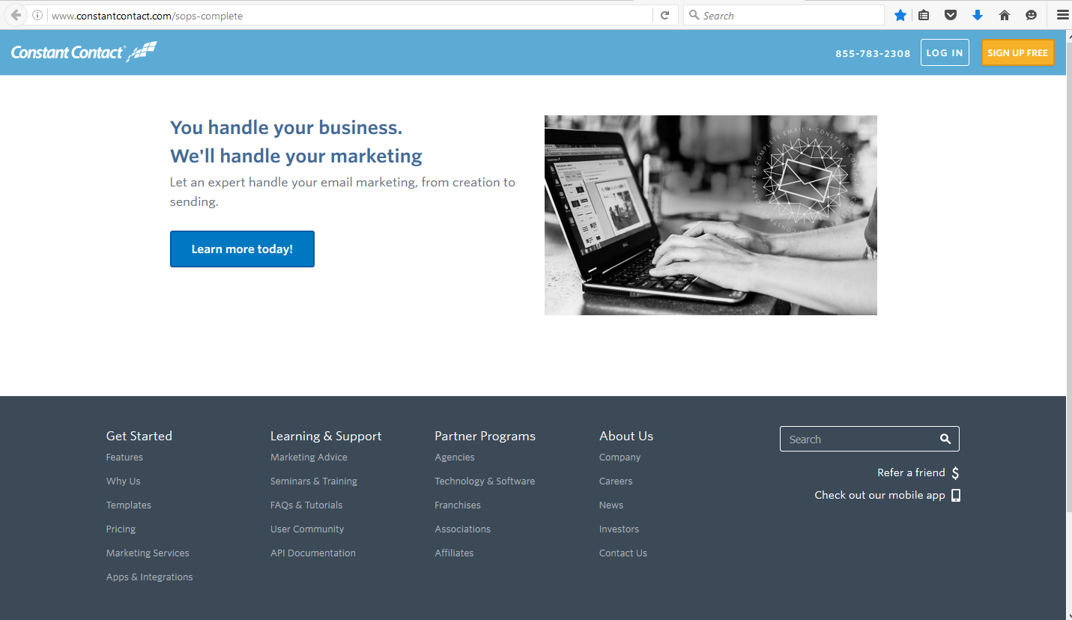
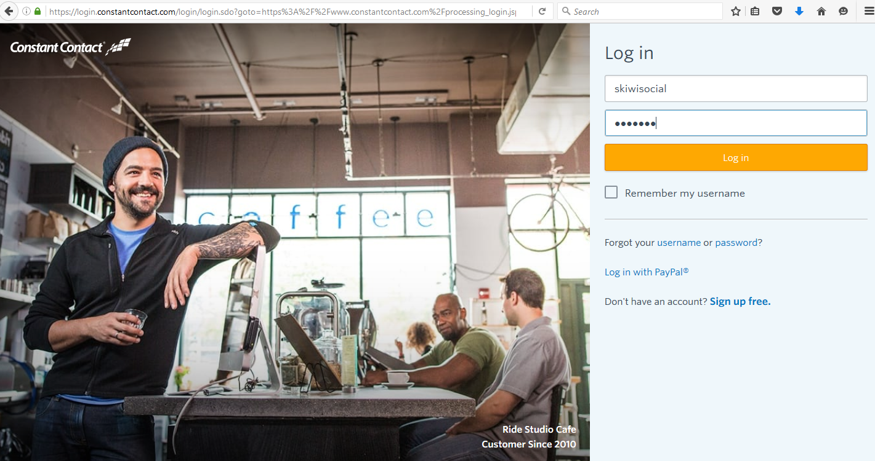
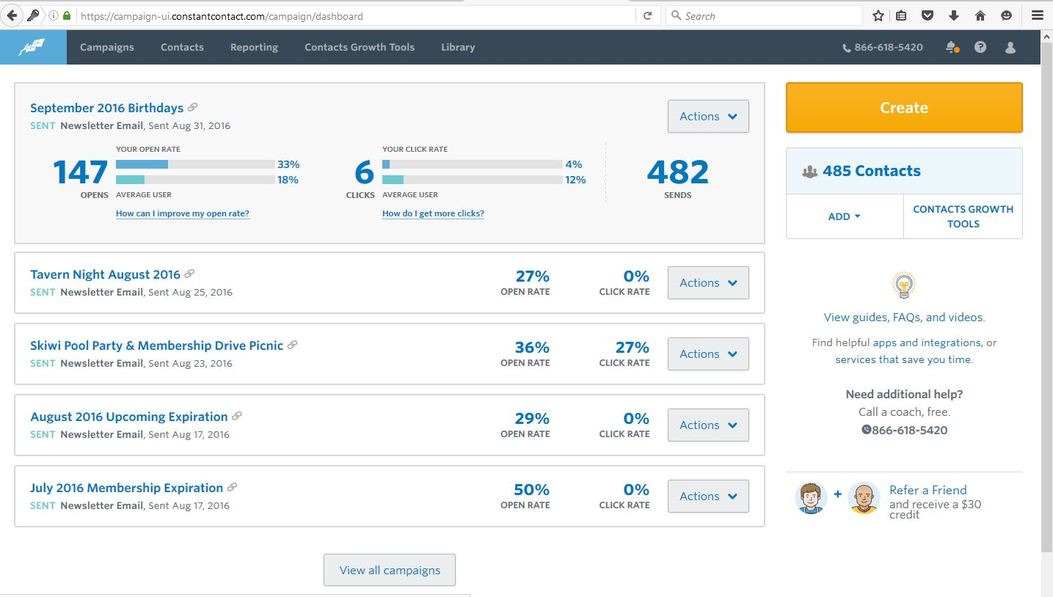

Choose an existing email and click on ‘Actions’ then ‘Copy’, then change the name:
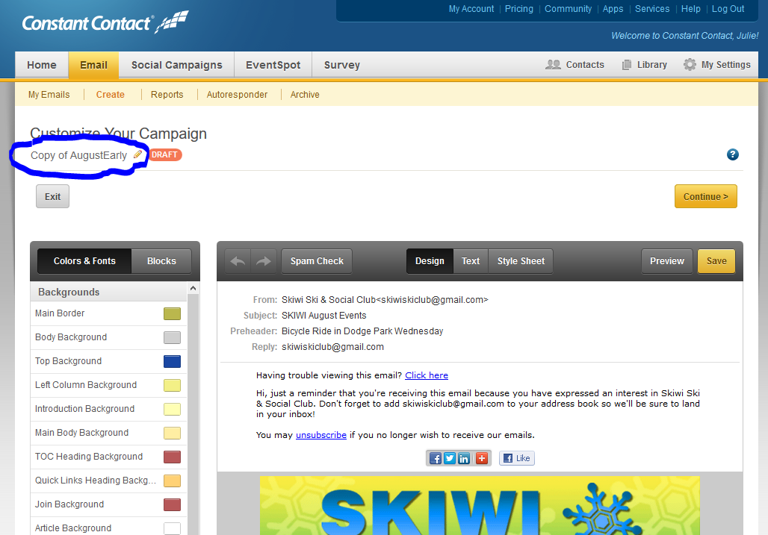
To change the name, click on the name and enter the new name

You will now be in edit mode for this email.

………………………………………………………………………………………………………………………………………………………………………………………………………………………………………………………………………………………………………………………………………………………………………….

You can hover over the ‘header’ are then click on Header Options to change the subject for the email
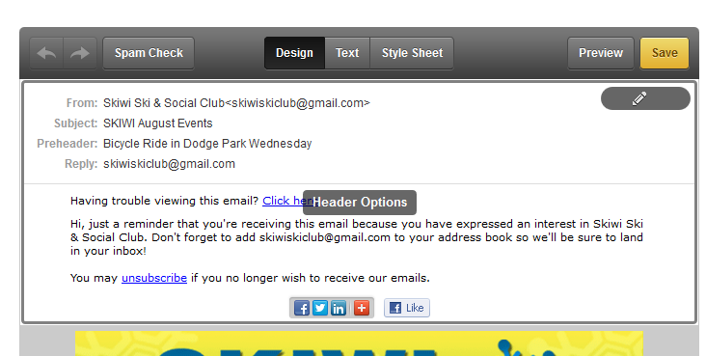

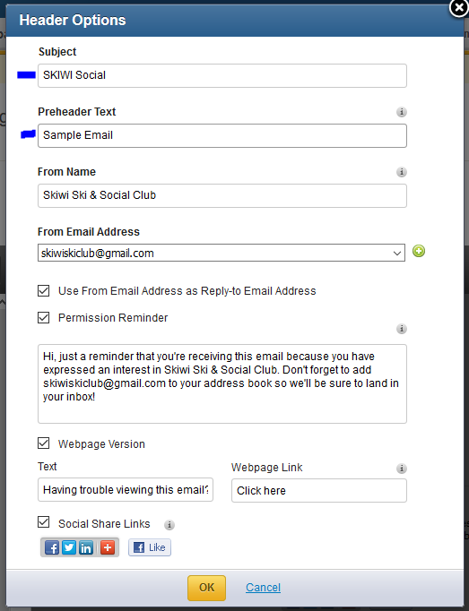 Click OK

Scroll down and click into a ‘Promotion Block’ that you want to edit. Usually we start with the same promotion block for the first one and change the text to summarize what the email is about and indicate more information is below:
The Promotion Block will open up in an edit mode, highlight the text you want to change and replace with new text:
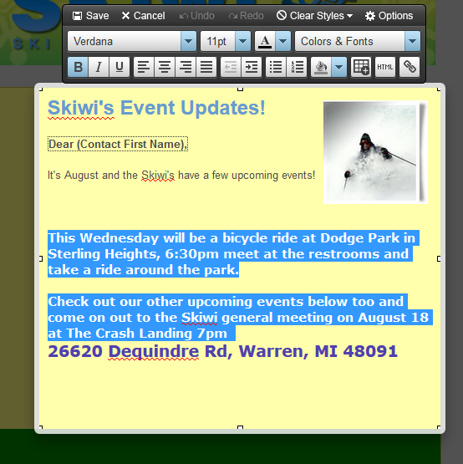
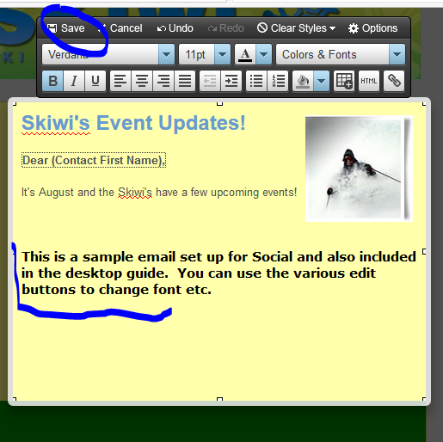
Click on Save when finished

This same operation can be performed on the other Promotion Blocks after the first one. You can click and drag the blocks up/down to reposition them or you can delete an entire block. (you can also add a new block)

Click on a block to change it. You can click on an object/picture and edit/change it:
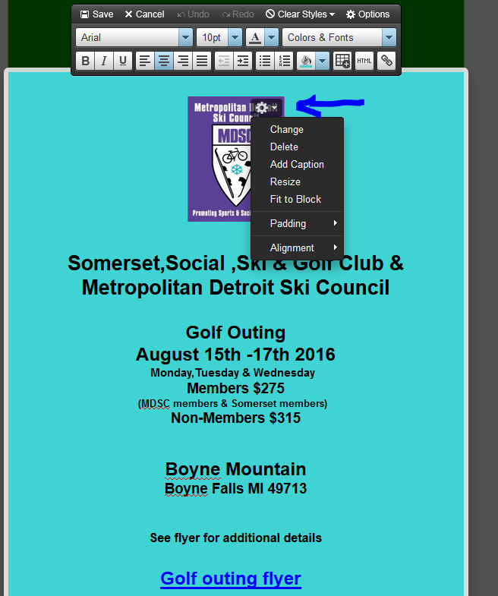

To change a flyer, highlight the text where a flyer is linked, change the text, then choose Document Link to open the dialog box where you can choose an existing document(PDF) or upload a new one:

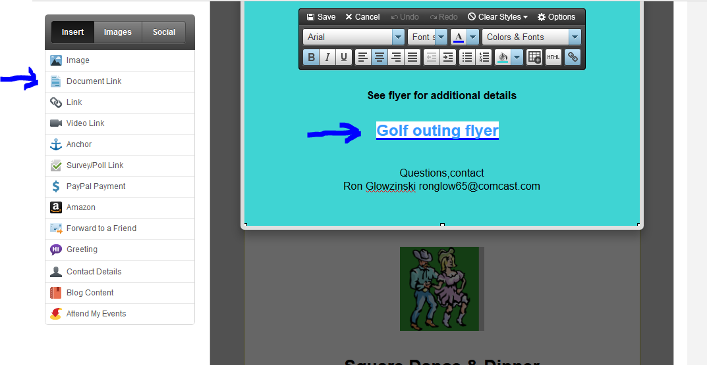

After you click on Document Link, it will give you a list of documents stored on CC or ask to upload a new one. If you choose to upload a new one, select ‘from your computer’ then navigate to the document and click on it, a confirmation box will open:
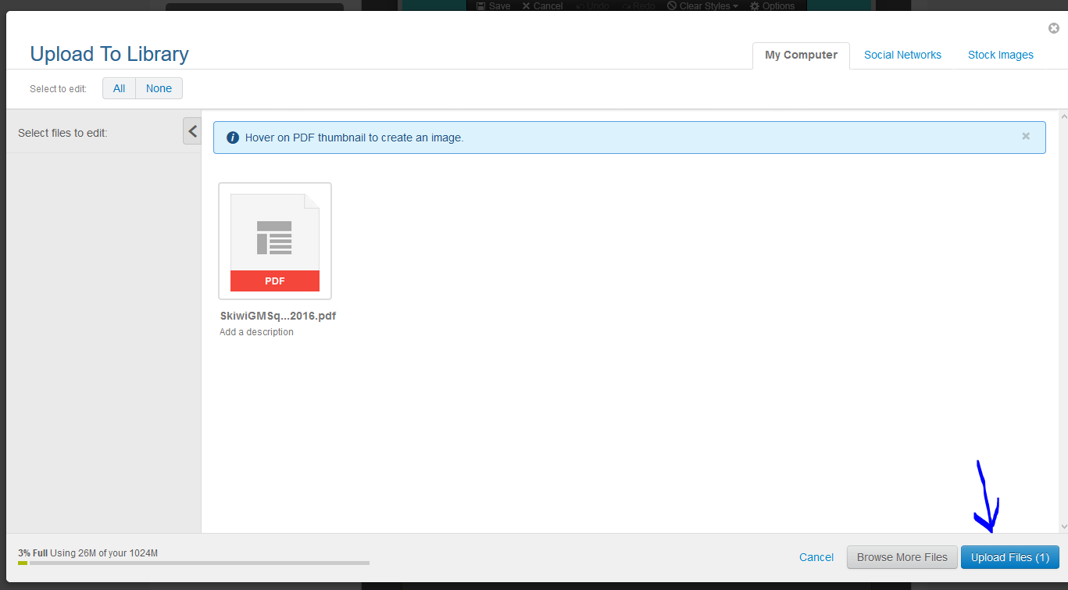

Choose Upload then Done and it will put you back into the list of documents where you can choose the document you just uploaded, click on the circle next to the document then click Insert:
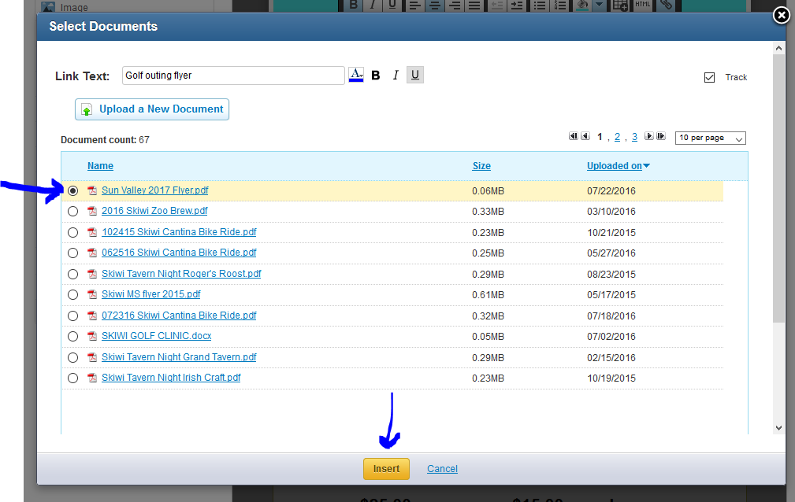

Now you can click Exit and the email is saved as a Draft, or you can click on Continue and “Schedule” the email for delivery.

If you saved as a draft you can go back and select it for further editing or you can click on the Schedule button and set it up to send out. Send to the General Interest and Member lists.

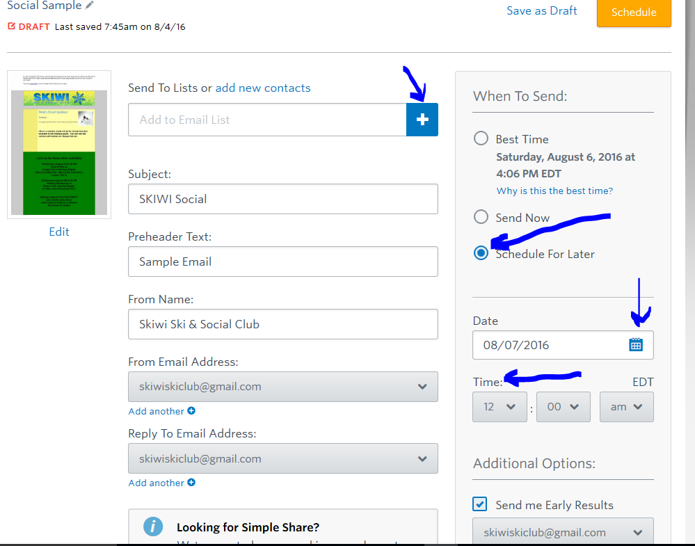

Click on Schedule when finished setting up, or save as a draft.

Log out and you are done, sit back and wait for an email!

