SKIWI Google Calendar Updates

Sign onto the Skiwi Gmail account
(SkiwiSkiClub@gmail.com)

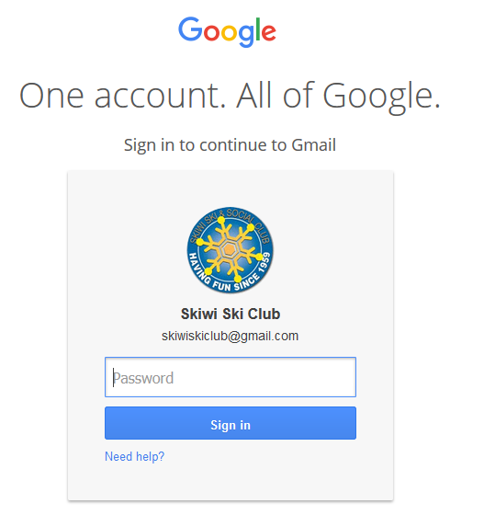

Click on the “Apps” icon to expand other choice then click on the Calendar icon:
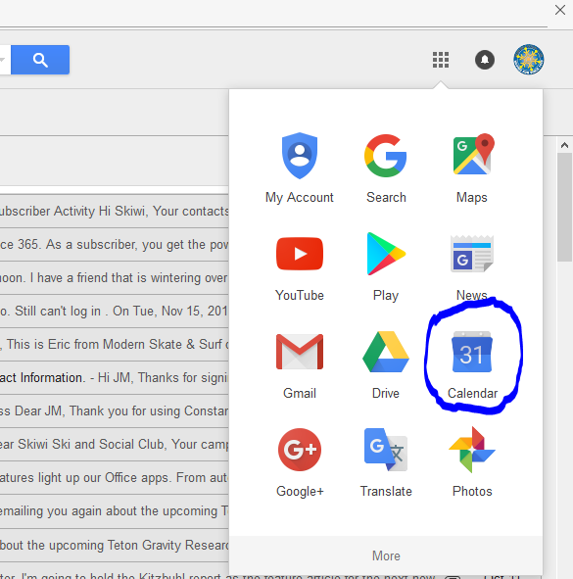

Click on any day in the calendar to create a new event. When the event opens, type a subject and try to put the name and where it is at so Google can automatically insert a map for the event.
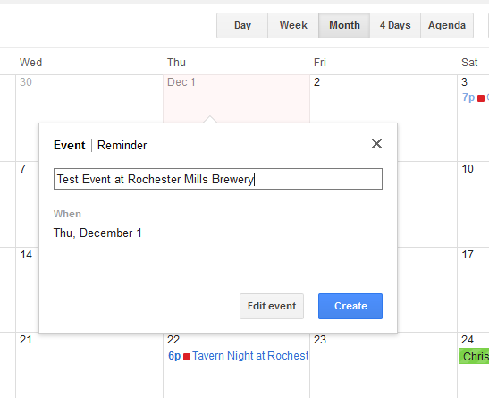
Click on ‘Edit event’ to open and add details. When the event opens, unclick “All Day” and set a time range for the event, add a description, change the font color for the event, and make the visibility “Public”:
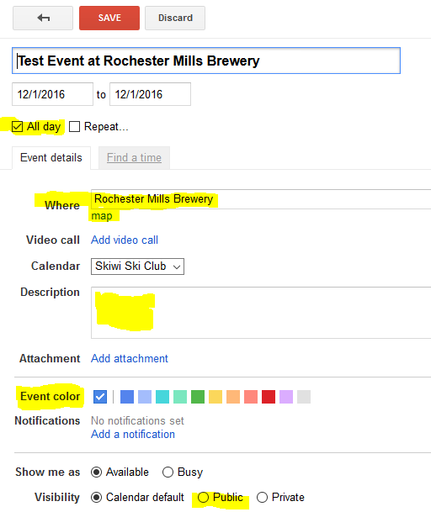
Notice the ‘Where’ has a map from Google already inserted. Click on SAVE when finished (or Discard)

