Skiwi Web Site Notes

Log onto Weebly.com with SkiwiSkiClub@GMail.com and [password]

Once logged in, choose “Edit Site”
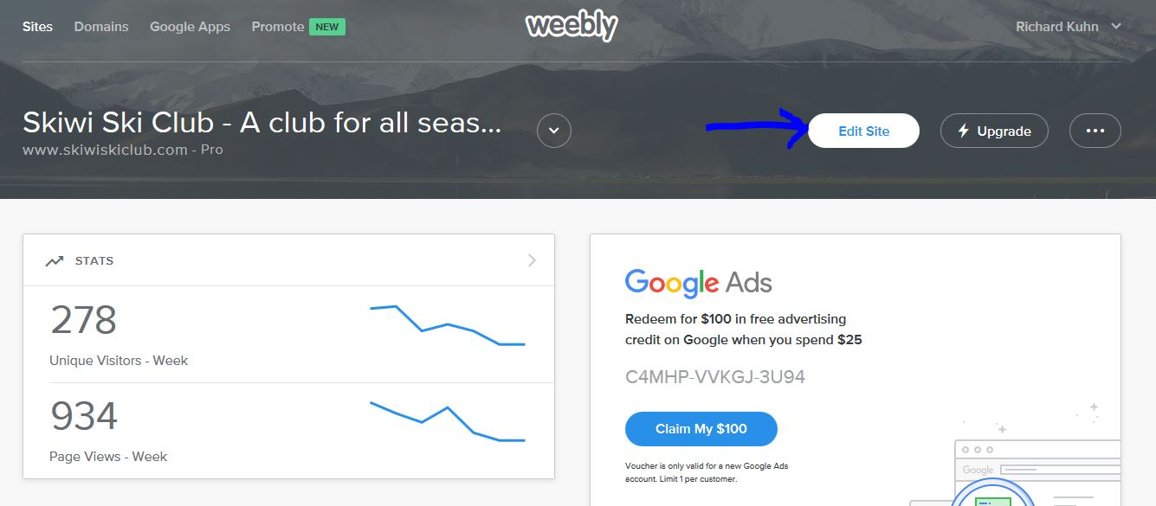

This will open the web site to edit, it will look similar to the actual home page on the web site but will have editing tools on the left hand side
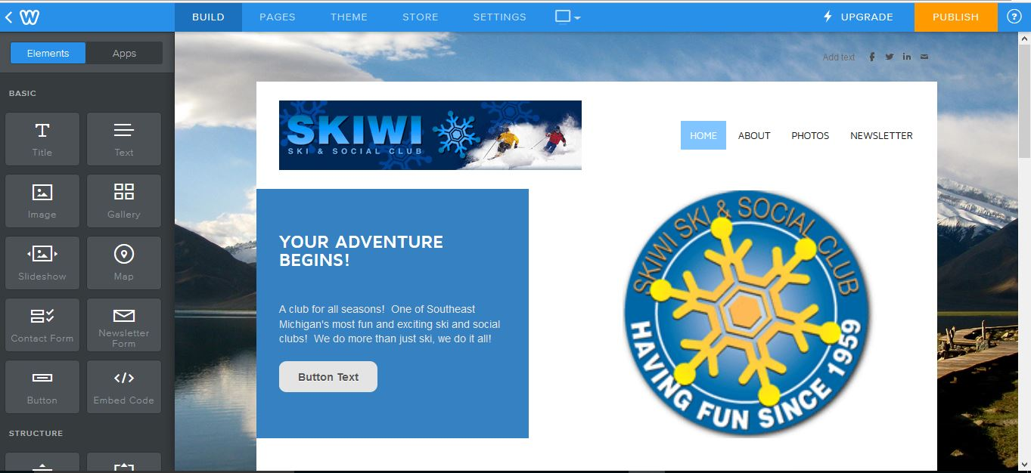

To navigate to the page you want to edit, use the menu navigation buttons just like you would navigate on the web.
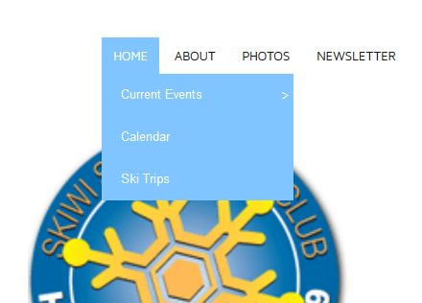

Have all content such as flyers or artwork saved in a folder so you can easily find it while editing. You can always swap over to Windows Explorer and put things in while you are working. The key thing here is to always keep your content in a central location so you can find it and refer back to it.

Most updates will be to the “Current Events” page. Other pages that get updated often are “sub pages”under Current Events: “Cantina Bicycle Rides” and “Tavern Nights”. The “Ski Trips” page is updated when trips are announced, then changed after the season is over to indicate the trips listed are from the previous season and to check back next season when the trips are posted, usually in August. The “Newsletter” page will be updated when newsletters are published, currently the plan is to have them done seasonally or quarterly. The “Photos” page is usually updated after ski season with trip photos and other photo pages occasionally to summarize/capture past events. Under the “About” page is the “Racing” page, that gets updated prior to the race season to announce the racer meeting, during the season to post results and after the season for the final results. Most other pages are ‘static’ and only changed if necessary, i.e. Home, Contact, General Meeting, Join, etc.

The “Calendar” page is not updated from the Weebly site, it is updated using the Skiwi Google account by accessing that calendar. There are separate notes on how to update the calendar, the updates will show up automatically (or dynamically) on the web site when the calendar is updated. The calendar is on the Home page and on the “Calendar” page too.

Have a ‘plan’ on what you are going to update. Make a list of updates in the order they should show up on the page you are editing. For example, when updating the Current Events page, which typically has several events, list them in order by date with the most current events at the top of the page. It is acceptable to place some special announcement at the top of the page above all the events to draw attention to information listed below, but do not put the entire item above all other events. For example, you could have something like this: “Attention! The XYZ Event is almost sold out! See below for details”

These screen shots show the other pages that can be accessed from the navigation bars:
“Home” Navigation Pages (Current Events => Cantina Bicycle Rides & Tavern Nights; Calendar, Ski Trips):
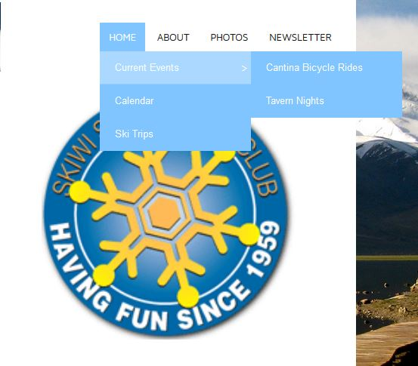

“About” Navigation Pages(General Meeting, Racing, Join, Contact, Links Sponsors Ads):
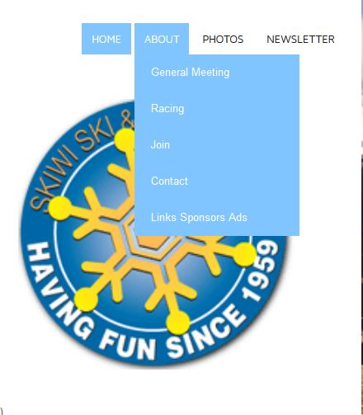

The “Photos” and “Newsletter” pages are stand-alone pages accessed from the Home page.

Updating a Page
Since the ‘Current Events’ page is the page most often updated, that is the page which will be used for this example.

Navigate to the page you want to edit, in this case it will be the Current Events page.

Pages are set up with Text Boxes which contain text, pictures and links. Links can be set up to open a flyer, take you to another page or open pages on other web sites.

Scroll down on the page to see where the text boxes are located:
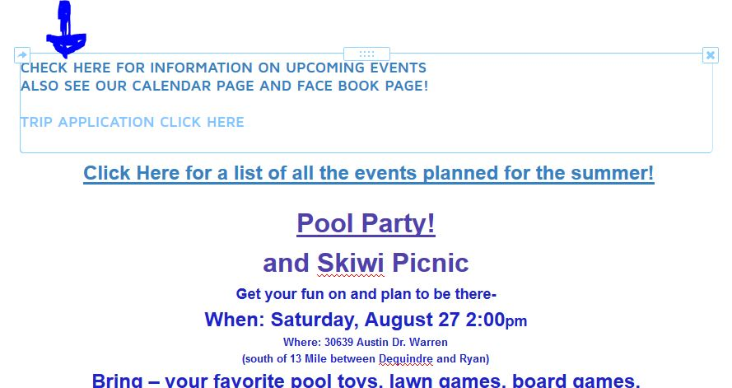Notice the text box is highlighted.

Click anywhere in the text box to put focus on the box for editing the content, a menu bar will open which allows you to edit the various parts in the text box. You can change fonts and colors or create links.

Here is what the menu bar looks like, from the left the buttons are for:
BOLD, Italics, Underline, Increase Font Size, Decrease Font Size, Change Font Color, Link Text, Text Alignment, Bullets, Numbers, Remove Formatting, Undo and Redo
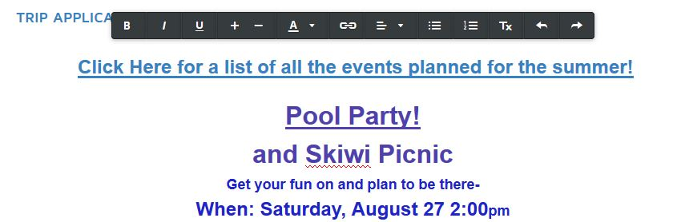

(Note: at this time inserting pictures to the text boxes is shifting the content on the Current Events page. For this reason no graphics are being put on the page, just text and links to flyers: This has been corrected but be aware it happened, but what changed to correct is unknown!) Generally add text to the box, then insert (drag the icon for a photo) pictures, the text may shift and you might have to realign it or re-orient it in relation to the inserted picture.

Highlight the text you want to edit and use the menu bar to format. You can “scrape” (copy) text from a word document or other source the paste it into the text box, it will most likely lose any formatting from the source document and you will need to reformat it.

When listing events follow the following guidelines of the 5 W’s & 1 H

- Use BOLD font on all text, except email entries.
- Put the Event Name or Title on the first line by itself (What)
- Put the Day, Date and Time under the Event Name (When)
- Put the Event Location next (Where)
- Put the Event Details next (Why)
- Put Event Payment info next (How)
- Put Contact Info last with host name, phone and/or email (Who)

Formatting Tips
- Highlight the text to format and use the menu bar to change
- Set the Event Name or Title in larger font and underline if you will be linking it
- Make all text bold except email entries
- Change the color using the menu bar, click on the “A” and it will open a box for choosing the color:
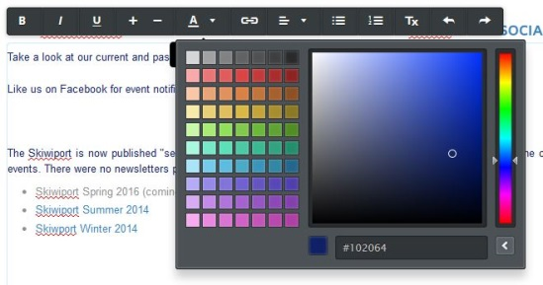
- Use the “color bar” on the right to select a range of color to choose from, then click in the large square to choose the actual color. (note: there may be a better way to change text color, this will be researched) Generally use a darker blue for Event Names & Titles then a slightly lighter shade for the 5 W’s & 1 H info.

Create links on the Event Name or Title.
- Highlight the text to link
- Click on the Link symbol (a chain link) on the menu bar to open the link dialog box
- Choose the type of item you want to link to, it can be a PDF(file) or a Website (URL)
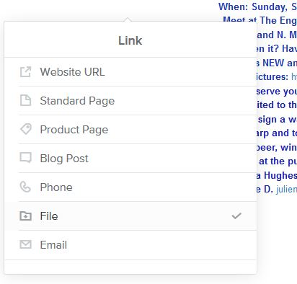
- You can upload a new item or choose it from your computer
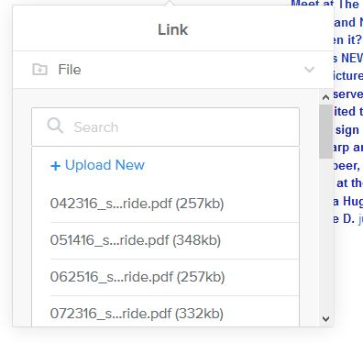
- Finally, after selecting the item scroll down to the bottom of the dialog box and you can check the box to ‘open in a new window’ or leave it unchecked. Generally choose to open a new window.

