Skiwi Ski Club Website Log In for Secure Access

The website has some secure pages set up to hold various documents for which a “Log In ID” and password is required. The website has an area to hold the accounts or logon ID’s which are email addresses. The passwords for each ID are managed behind the scenes as a service from Weebly which is the club’s web site host. The passwords are something each account sets and manage. If a password is forgotten this service will provide a service to send the account a link for resetting the password. The Web Maintainer or Web Master (if you prefer!) is responsible for adding people to the list and sending out email notifications with the link for initial access. Links can also be sent by the Admin if an account has not accepted the “invite”

Access to the secure pages is done by clicking on the “Log In’ button located at the top right of the page. When you click it and log in, the following choice will be presented to you for access to the secure pages:

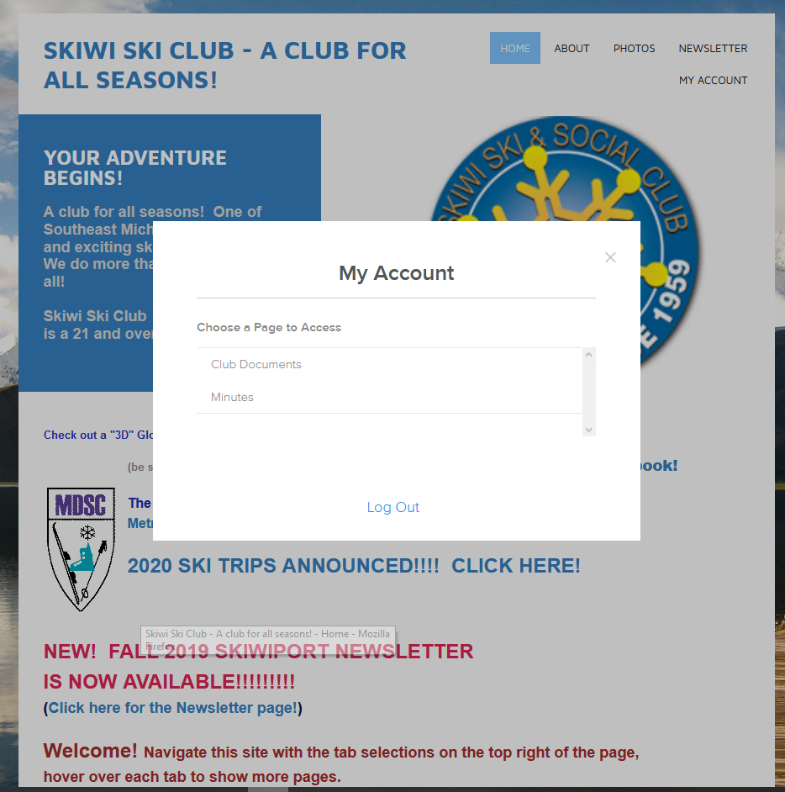
Click on the page you want to access or Log Out.

Managing account access

Accounts can be added to the Members list under Settings:

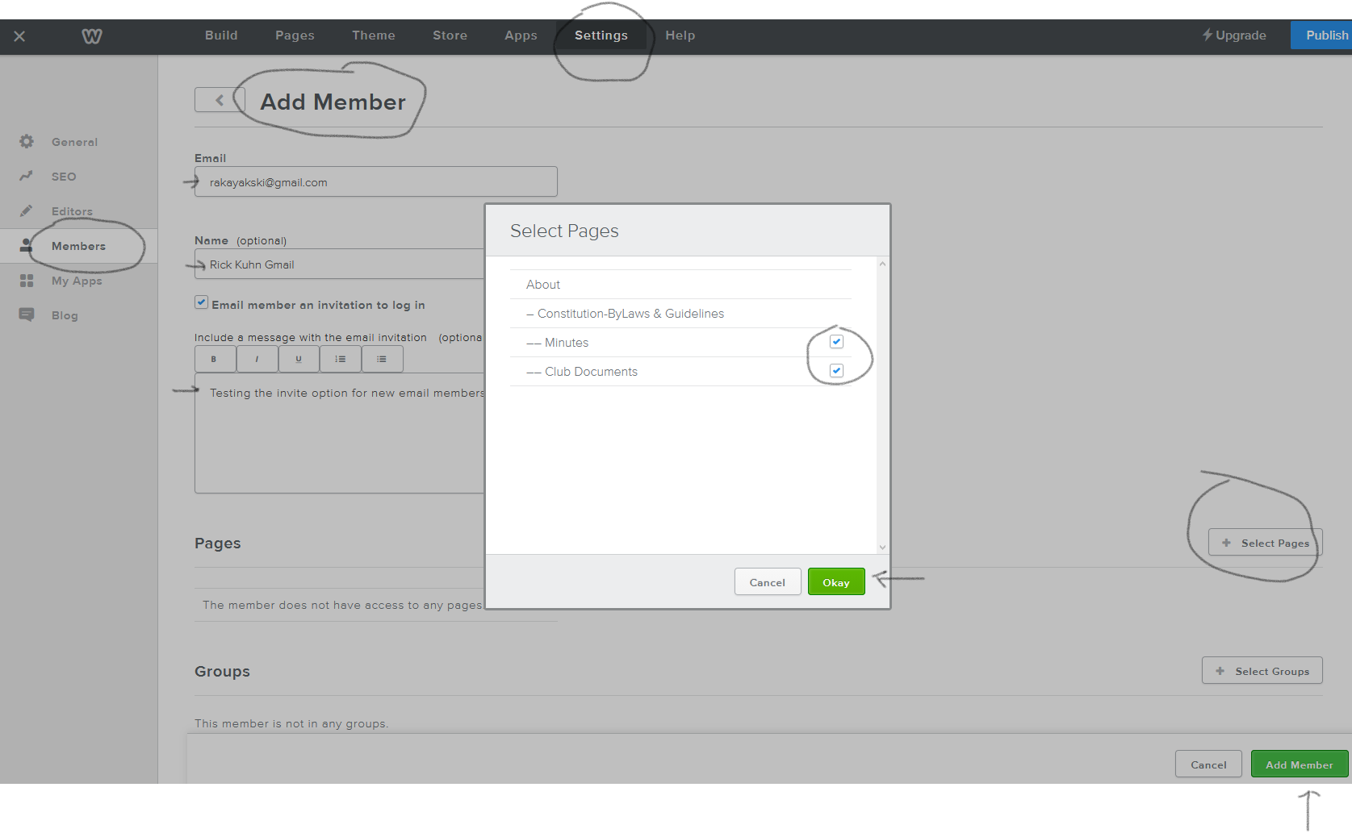

This function will automatically send an email when the person is added using this method.

You can access the Member List and do several operations. You can create a link and copy/paste it then send an email out to the Member(Account) so they can reset their password and log in.
If a member has already accepted their Invite, you can manage that account by clicking on the account.
